[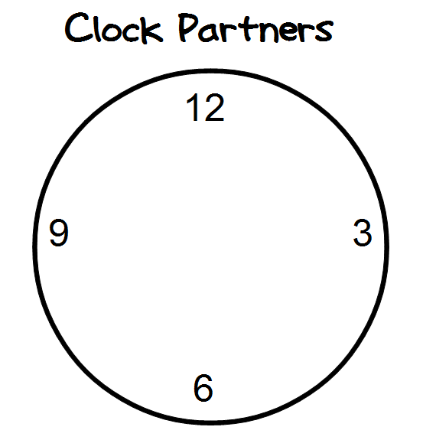](http://2.bp.blogspot.com/-ngoBks5kCkw/UHOHbu1S5-I/AAAAAAAAAoA/tdmx9EoB8Wo/s1600/Untitled+1+-+OpenOffice.png)