Solve It!
Use the chart from the reading to convert the units in the questions below. Paste this page to page 21 of your science notebook. Paste the article and chart to page 22.

- Convert 104.3 centimeters to millimeters.

- Convert 37 kilometers to meters.

- Convert 27.45 milliliters to liters.

- Convert 315.75 grams to kilograms.

- Convert 150 grams to hectograms.

Solve It!
Use the chart from the reading to convert the units in the questions below. Paste this page to page 21 of your science notebook. Paste the article and chart to page 22.

- Convert 104.3 centimeters to millimeters.

- Convert 37 kilometers to meters.

- Convert 27.45 milliliters to liters.

- Convert 315.75 grams to kilograms.

- Convert 150 grams to hectograms.

Converting Measurements
If you have a prescription for 5,000 mg of medicine, and upon getting it filled, the dosage reads 5 g of medicine, did the pharmacist make a mistake? To solve this problem, you need to know how to convert from one measurement to another as well as how to add different quantities together.
The basic metric units are meters (for length), grams (for mass or weight), and liters (for volume). And the different units convert into one another rather nicely, with one milliliter equaling one cubic centimeter (the "cc" of medical shows on television) and one gram being the weight of one cc of water.
There are many metric-unit prefixes, but the usual ones required in school are these:
kilo-, hecto-, deka-, deci-, centi-, and milli-.
To convert between the various prefixes, and thus the variously-sized units, you just move up and down this list of prefixes, moving the decimal point as you go.
To remember the prefixes in order, you can use the following sentence:
King Henry Doesn't [Usually] Drink Chocolate Milk
The first letters of the words stand for the prefixes, with "Usually" in the middle standing for the "unit", being meters, grams, or liters. Many memory phrases omit the "Usually", and consequently students forget where the basic unit goes, messing up their conversions. Leave the "Usually" in there so you can keep things straight: kilo-hecto-deca-[unit] deci-centi-milli
Since each step is ten times or one-tenth as much as the step on either side, we have:
1 kilometer = 10 hectometers = 100 decameters = 1000 meters = 10 000 decimeters = 100 000 centimeters = 1 000 000 millimeters
The point here is that you move from one prefix to another by moving the decimal point one place, filling in, as necessary, with zeroes. To move to a smaller unit (a unit with a prefix some number of places further to the right in the listing), you move the decimal place to the right that same number of places, and vice versa. Together with the prefix sentence ("King Henry..."), this makes conversion between the different metric sizes very simple.
Example:
Convert 12.54 kilometers to centimeters.
How many jumps is it from "kilo-" to "centi-"? Five, to the right.
Kilo- hecto- deka- unit deci- centi- milli- 12.54000.
5
4
3
2
1
Answer: 12.54km = 1254000 cm
Converting Measurements
If you have a prescription for 5,000 mg of medicine, and upon getting it filled, the dosage reads 5 g of medicine, did the pharmacist make a mistake? To solve this problem, you need to know how to convert from one measurement to another as well as how to add different quantities together.
The basic metric units are meters (for length), grams (for mass or weight), and liters (for volume). And the different units convert into one another rather nicely, with one milliliter equaling one cubic centimeter (the "cc" of medical shows on television) and one gram being the weight of one cc of water.
There are many metric-unit prefixes, but the usual ones required in school are these:
kilo-, hecto-, deka-, deci-, centi-, and milli-.
To convert between the various prefixes, and thus the variously-sized units, you just move up and down this list of prefixes, moving the decimal point as you go.
To remember the prefixes in order, you can use the following sentence:
King Henry Doesn't [Usually] Drink Chocolate Milk
The first letters of the words stand for the prefixes, with "Usually" in the middle standing for the "unit", being meters, grams, or liters. Many memory phrases omit the "Usually", and consequently students forget where the basic unit goes, messing up their conversions. Leave the "Usually" in there so you can keep things straight: kilo-hecto-deca-[unit] deci-centi-milli
Since each step is ten times or one-tenth as much as the step on either side, we have:
1 kilometer = 10 hectometers = 100 decameters = 1000 meters = 10 000 decimeters = 100 000 centimeters = 1 000 000 millimeters
The point here is that you move from one prefix to another by moving the decimal point one place, filling in, as necessary, with zeroes. To move to a smaller unit (a unit with a prefix some number of places further to the right in the listing), you move the decimal place to the right that same number of places, and vice versa. Together with the prefix sentence ("King Henry..."), this makes conversion between the different metric sizes very simple.
Example:
Convert 12.54 kilometers to centimeters.
How many jumps is it from "kilo-" to "centi-"? Five, to the right.
Kilo- hecto- deka- unit deci- centi- milli- 12.54000.
5
4
3
2
1
Answer: 12.54km = 1254000 cm
Watch It!
Watch the video found here: https://drive.google.com/file/d/0BxOms4hIDvR3TWkxTW5NdUZadkk/view
Respond to the questions below and paste this to page 24 in your science notebook.

- Describe the difference between accuracy and precision.

- What efforts do doctors and engineers have to take in order to be both accurate and precise?

- Why is NASA now more accurate and precise with their Martian landings?

Watch It!
Watch the video found here: https://drive.google.com/file/d/0BxOms4hIDvR3TWkxTW5NdUZadkk/view
Respond to the questions below and paste this to page 24 in your science notebook.

- Describe the difference between accuracy and precision.

- What efforts do doctors and engineers have to take in order to be both accurate and precise?

- Why is NASA now more accurate and precise with their Martian landings?

Research It!
Visit the following website: http://www.texasgateway.org/node/3972
Read the information about graduated cylinders and respond to the questions below. Complete the questions at the bottom of the reading and record your answers below. Paste this to page 23 of your science notebook.
- What is a graduated cylinder used for?

- What is the meniscus? How is it used to read liquid volume in a graduated cylinder?

- Record your volumes below.

___________ ____________ ____________

___________ ____________ ____________

Research It!
Visit the following website: http://www.texasgateway.org/node/3972
Read the information about graduated cylinders and respond to the questions below. Complete the questions at the bottom of the reading and record your answers below. Paste this to page 23 of your science notebook.
- What is a graduated cylinder used for?

- What is the meniscus? How is it used to read liquid volume in a graduated cylinder?

- Record your volumes below.

___________ ____________ ____________

___________ ____________ ____________

Perform It!
With your group, use the number cards and decimal to show how to convert your base unit to the units in the chart below. Paste this to page 25 of your science notebook.
Convert 45.6 m to the units displayed in the chart.
Base Unit (m) | Centimeter (cm) | Kilometer (km) | Millimeter (mm)
Which direction did you move from your starting base unit?
How many spaces did you move in that direction?
What is the correct conversion answer?

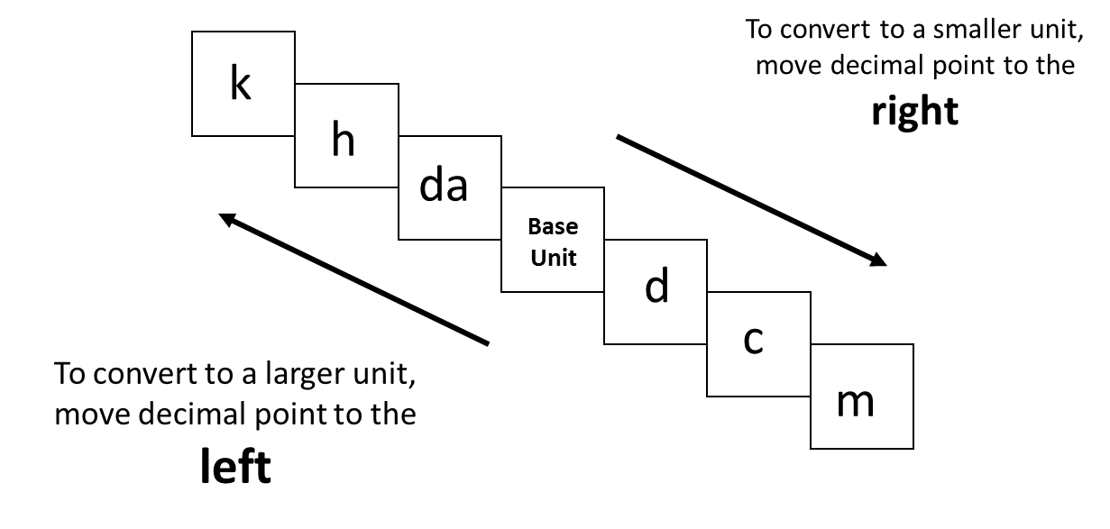

Perform It!
With your group, use the number cards and decimal to show how to convert your base unit to the units in the chart below. Paste this to page 25 of your science notebook.
Convert 45.6 m to the units displayed in the chart.
Base Unit (m) | Centimeter (cm) | Kilometer (km) | Millimeter (mm)
Which direction did you move from your starting base unit?
How many spaces did you move in that direction?
What is the correct conversion answer?

Read It!
Read the article provided about the history of the metric system. Then, write a summary explaining why the metric system was created and what its creation did for society. Minimum 3 complete sentences. Paste this to page 27 of your science notebook. Paste the article to page 28.

Summary: Why was the metric system created? What did the metric system do for society?

______________________________________________________________________________________________________________________________________________________________________________________________________________________________________________________________________________________________________________________________________________________________________________________________________________________________________________________________________________________________________________________________________________________________________________
Read It!
Read the article provided about the history of the metric system. Then, write a summary explaining why the metric system was created and what its creation did for society. Minimum 3 complete sentences. Paste this to page 27 of your science notebook. Paste the article to page 28.

Summary: Why was the metric system created? What did the metric system do for society?

______________________________________________________________________________________________________________________________________________________________________________________________________________________________________________________________________________________________________________________________________________________________________________________________________________________________________________________________________________________________________________________________________________________________________________
The metric system was developed in the 1700’s by a French chemist named Lavoisier as a way to replace the varied measurement systems used in various cities and countries with a more unified system that everyone could adopt and understand. It came from natural properties like the weight of water and size of the earth and became widely adopted across Europe soon after its creation. The metric system was created for several reasons which are highlighted below.
Powers of Ten: In the traditional U.S. system, when converting between inches and yards or feed and inches, there are complicated fractions that make measurements difficult to understand. SI units are all multiples of TEN. It’s a simple movement of the decimal from left to right or right to left as numbers are converted.
Prefixes: Base units of SI measurement include meter, gram, or liter. As you move the decimal, the prefixes to the base unit change, BUT they remain constant between meters, grams, and liters. Prefixes include mega, kilo, hector, deca, deci, centi, milli, and micro. It is easy to understand a kilometer (1000 x a meter in length) and a kilogram (1000 x a gram in mass) as they share the same prefix. It also makes conversion so much easier as well since each prefix stands for a multiple: kilo = thousand, centi = hundredth, milli = thousandth.
It's Universal: The metric system was created in a neutral format so it could be adopted and used by everyone no matter what country, nationality, rule, government, etc.
Easy to communicate and replicate: Because the metric system is primarily used in math and science, it allows for ease of communication amongst scientists no matter what their language or cultural barriers. It also created a consistency among measuring tools – graduated cylinder measures volume in liters, triple beam balance measures mass in grams, ruler measures length in meters. This consistency made it easier for scientists to replicate experiments and share their findings with one another as their data is easy to understand.

The metric system was developed in the 1700’s by a French chemist named Lavoisier as a way to replace the varied measurement systems used in various cities and countries with a more unified system that everyone could adopt and understand. It came from natural properties like the weight of water and size of the earth and became widely adopted across Europe soon after its creation. The metric system was created for several reasons which are highlighted below.
Powers of Ten: In the traditional U.S. system, when converting between inches and yards or feed and inches, there are complicated fractions that make measurements difficult to understand. SI units are all multiples of TEN. It’s a simple movement of the decimal from left to right or right to left as numbers are converted.
Prefixes: Base units of SI measurement include meter, gram, or liter. As you move the decimal, the prefixes to the base unit change, BUT they remain constant between meters, grams, and liters. Prefixes include mega, kilo, hector, deca, deci, centi, milli, and micro. It is easy to understand a kilometer (1000 x a meter in length) and a kilogram (1000 x a gram in mass) as they share the same prefix. It also makes conversion so much easier as well since each prefix stands for a multiple: kilo = thousand, centi = hundredth, milli = thousandth.
It's Universal: The metric system was created in a neutral format so it could be adopted and used by everyone no matter what country, nationality, rule, government, etc.
Easy to communicate and replicate: Because the metric system is primarily used in math and science, it allows for ease of communication amongst scientists no matter what their language or cultural barriers. It also created a consistency among measuring tools – graduated cylinder measures volume in liters, triple beam balance measures mass in grams, ruler measures length in meters. This consistency made it easier for scientists to replicate experiments and share their findings with one another as their data is easy to understand.

Watch It! #2
Visit the following link: https://goo.gl/Qf3MGz
Watch the video and respond to the questions below.

- Why did NASA accidentally crash an orbiter into the surface of Mars?

- What replaced Roman Numerals and fractions in Europe?

- Because Britain resisted France’s SI units for so long, what happened to colonial America?

- America is one of only ______ countries who have not embraced the metric system.

- Do you think America should join the rest of the world and convert to metric units? Explain your answer.

Watch It! #2
Visit the following link: https://goo.gl/Qf3MGz
Watch the video and respond to the questions below.

- Why did NASA accidentally crash an orbiter into the surface of Mars?

- What replaced Roman Numerals and fractions in Europe?

- Because Britain resisted France’s SI units for so long, what happened to colonial America?

- America is one of only ______ countries who have not embraced the metric system.

- Do you think America should join the rest of the world and convert to metric units? Explain your answer.

